Golf at School

Since opening in 2008 St Bees School have invested heavily in developing some of the most advanced Golf Training Facilities that any Independent School in Britain can only wish for. They now have an Indoor Golf Studio, Indoor Putting Green and Short Game Area on the main School Campus; which proudly compliment their own 9 Hole Golf Course which was built back in 1929.

The School’s PGA Golf Professional/Director of Golf has created, what he seriously considers, the most structured Golf Programme that any Independent School in Britain has to offer; and with the fabulous Education that St Bees School has to offer it comes as no surprise that they are beginning to attract a number of fabulous golfers from within the UK and abroad.

Last year’s Golf Team:

- Won the U15 Nett Team Trophy at the ISGA Scottish Open
- Finished 2nd overall in the Nett Division at the ISGA Scottish Open
- Year 10 student, Nathan Thompson, from Georgia in the US won the overall and U15 Nett Trophy at the ISGA Scottish Open
- Were Runners Up in the North Region Area Finals in the ISGA Matchplay Championship, narrowly losing to Merchant Taylors, a large Day School from Liverpool

With the New School Year now in full flow, St Bees School are looking forward to building on their success to date as a Golf Team and Golf Academy.

Under 16 County Player, Alex Rose, from Windermere Golf Club who plays off a Handicap of 4 has joined the Sixth Form on a Golf Scholarship as a Weekly Boarder. Alex has a tremendous record for the County Team and has won the Cumbria U16’s 36 hole Championship on the last 2 occasions. | 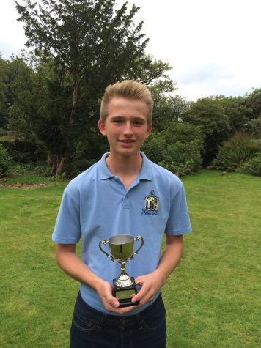

Zenon Kohs, a 15 Year Old from Berlin Germany, joins a number of other International Students at St Bees as a Full Boarder. Zenon plays off a Handicap of 1 and represents his Federal State, Brandenburg.

There is no doubt that golfers of this standard will certainly help them as they continue to strive towards competing on a National Level. However, it is the strength in depth that pleases the School’s PGA Golf Professional/Director of Golf, Stuart Hemmings the most. With over 50 students members of the Golf Academy, ageing from 4 – 18, the future looks bright.
Recently, on St Beghians’ Day, off the back of a generous donation from the Old St Beghians’ Golfing Society, some new technology was unveiled within the Golf Studio. The GC2 launch monitor/simulator as seen on Sky Sports, has just been fully installed into the School’s Golf Studio. Such technology will enable the student’s to play/practise on several Simulated Golf Courses such as: St Andrews, Carnoustie, Turnberry, Royal Birkdale, Congressional, Oakmont and more.

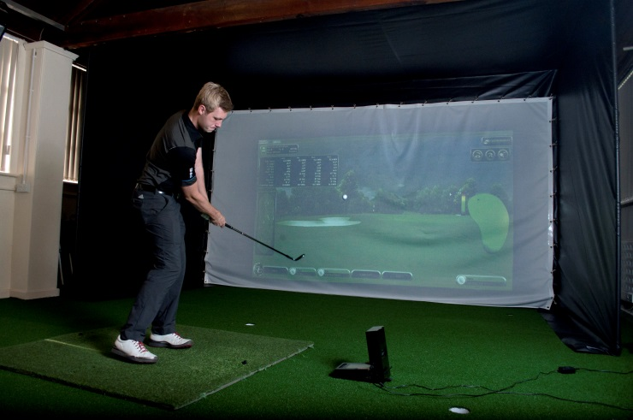 | 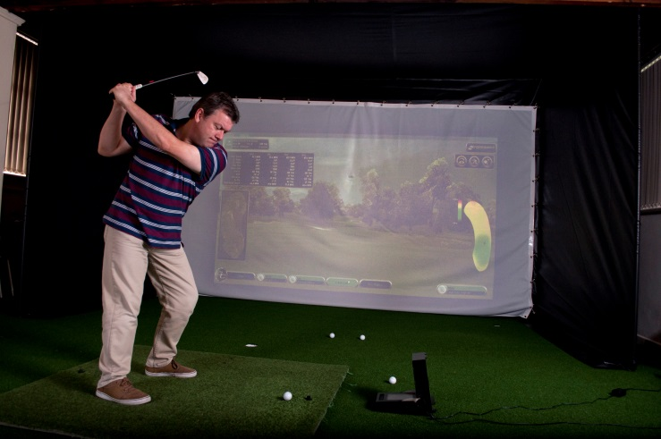

To cap off an incredible start to the New School Year the School’s 1st Team travelled to Silloth-on-Solway to play against Merchiston Castle, an all boys school from Edinburgh, ranked 3rd in the country by the ISGA in 2013-14. With the sun shining St Bees stepped up to the test Winning 3½ - 2½ in a tightly contested match.

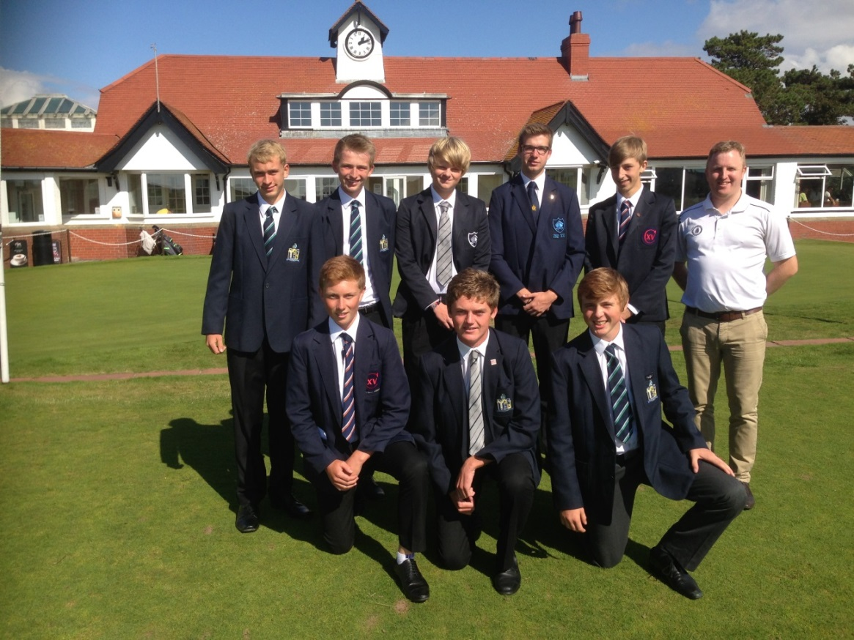

Stuart Hemmings,
Director of Golf.

